3

INDUSTRIAL SURVEYING

3

3

3

4

INDUSTRIAL SURVEYING

3

3

3

INDUSTRIAL SURVEYING

INDUSTRIAL SURVEYING

3

www.aksm.gr

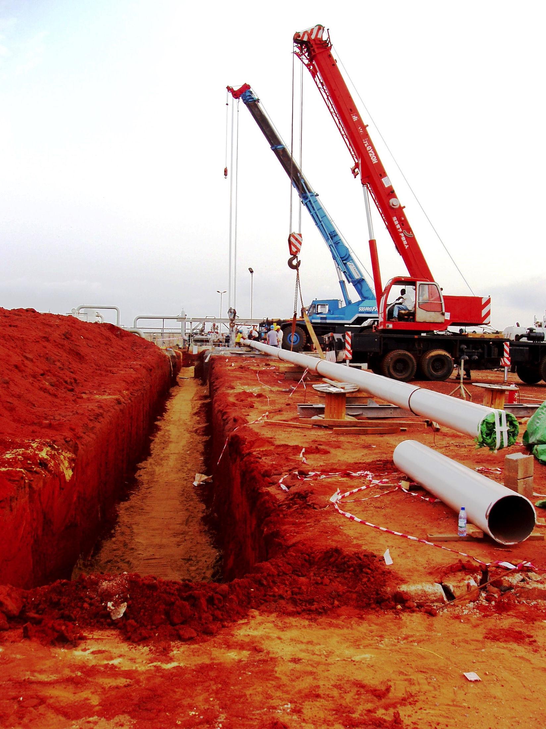

2

THE COMPANY

In today's complex construction environment our innovative expertise, analysis and carefully crafted approach can help bring security to construction process. AKSM implements high accuracy applications which allow us to survey with pinpoint accuracy for industrial projects.

Our experienced staff at AKSM supports manufacturers in a wide range of construction process in order to meet specifications in terms of precision. We provide measurement data with high precision for accurate information on the size, shape and position of objects. We can carry out spot on measurement on site with the advantage of the latest technology.

INDUSTRIAL SURVEYING

3

‘Alexandros Karditsas & partners

Surveying Consulting Servises’│AKSM│

392 Mesogeion Avenue│15341 Agia Paraskevi, Athens│GREECE

T: +30 210 9702510│F: +30 213 0285617│M: +30 694 4774491

info@aksm.gr

www.aksm.gr

Industrial

Surveying

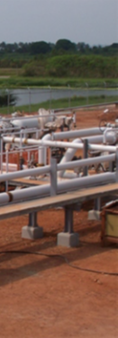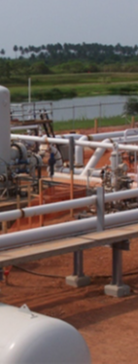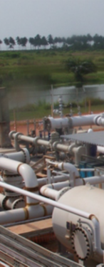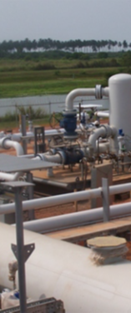

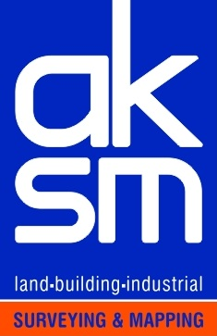

**SURVEYING PRECISION**

INDUSTRIAL SURVEYING

Surveying Precision

www.aksm.gr

INDUSTRIAL SURVEYING

INTUSTRIAL SURVEYING

6

7

 ‘Alexandros Karditsas & partners Surveying Consulting Services’|AKSM│ 392 Mesogeion Avenue | 15341 Agia Paraskevi, Athens| GREECE |

SURVEYING PRECISION

www.aksm.gr

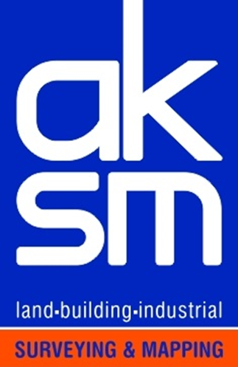T: +30 210 9702510| F: +30 213 0285617 | M: +30 694 4774491 | E-mail: info@aksm.gr